Euroeasy - Penalties Calculation Engine(PC) - Overview

**Euroeasy** is a financial company in EURPOEAN UNION (EU) that helps it’s customers and investors in Securities settlement services as an CSD (Central Security Depositors).

Central Securities Depositors Regulation (CSDR) has created a requirement for each CSD (Central Security Depositor) to charge a client a penalty for a settlement fail in EU region.

**Euroeasy** has approached Capgemini for building the ‘core’ **CSDR Penalties Engine** on distributed platform that will be responsible for penalties calculation for intra-CSD settlement failed transactions based on business rules.

Mainframe

PC-Backend





Report

Settlement Engine

screen

s

API/Svc Job

API/Svc Job

API/Svc Job

PC UI

Calc Job

Load Ref Data Job

DB

**CSDR** **Penalty Calculation Engine Architecture**

Scr een

screen

screen

\\E$\RefFiles

\\E$\TranFiles

Rule

Rule

Rule

**Actors**

|  |  |
| --- | --- |
| Name | Description |
| Business Users | Business Users of Euroeasy responsible for managing the ref data and edit penalties. |
| Business Users Approvers | Approve/reject edited penalties and ref data change. |

Penalty Calculation Backend Jobs

**Load Reference Data Job** : Feeds of Reference Data will be pushed to distributed environment from Mainframe system. **Load Reference Data Job** is responsible for reading all these reference data files from the shared location and load them into the database in the distributed environment.

Reference Data Feed template: <TBD>

**Penalty Computation Job:** This job is responsible for calculating penalties for the failed transactions based on business rules and reference data.

* Failed Transaction File Template:
  + 
* Rules:
  + Formula for Penalty calculation for a failed transaction is – Securities Qty involved in the failed transaction* Security price * security penalty rate
* Reference Data:
* Holiday Calendar
* Security Price
* Security Penalty Rate

Screen Specification

A local entity user can search and view all penalties calculated for its CSD participants (Intra CSD)or created based on report from another CSD (Cross- CSD).

The User Interface for internal operations, in terms of screens (presentation layer), will be standard ASP.Net MVC as it is standard enquiry and management functions. In addition, a further step away from the past implementations, we will be using APIs to execute the server side logic (instead of WCF services that was the norm previously) thus allowing (most of) these services to be used by other consumers.

**Penalties**

* View all penalty details
  + Securities & reference data that have been used for calculation
* Update Penalties
  + Remove
  + Update
* Validate or Reject updated penalties

**Reference Data**

* Reference Data CRUD operation
  + Holiday Calendar
  + Security Price
  + Security Penalty Rate

Reports

* Daily Penalty Report by Party
* Monthly Penalty Report by Party

|  |  |  |
| --- | --- | --- |
| Name | Type | Description |
| Place of Holding Tech number | Smallint | 10 |
| ISIN | CHAR (12) | ANN4327C1220 |
| Security quantity | int |  |
| Transaction Type Code | CHAR(4) | TRAD |
| Instruction Type code | CHAR(4) | DVP |
| Matching Reference | CHAR(16) | 776702220230112 |
| Settlement Date | Date |  |
| Place of Settlement | CHAR(11) | MGTCBEBEXXX |
| Settlement cash amount | Decimal |  |
| Calendar Id | CHAR (10) |  |
| Party Id | Char(16) | 1981854 |
| Counter Party Id | Char(16) | 4794041 |
| Party Role Cd | Char(6) | Seller |
| Counter Party Role Cd | Char(6) | Buyer |
| Failing Party Role Cd | Char(6) | Seller |
| Penalty Amount | Decimal |  |
| Sign | String | + or - |

API Specification

**Reference Data APIs** – APIs that provide reference data for penalty calculation ex: Holiday Calendar, Security Price, Security Penalty Rate etc.

**Penalty APIs** – APIs that provide penalty data for UI requirements.

**Report APIs** – APIs that provide data for report requirements.

Non-Functional Requirement

1. Exceptions in the system must be handled centrally.
2. .Net Core Logging Framework must be leveraged to implement logging across the system to troubleshoot issues.
3. All dependencies must be created using .NET Core Dependency Injection
4. Calls across the services in the system must be implemented using Asynchronously.

Definitions:

**What are Securities:**

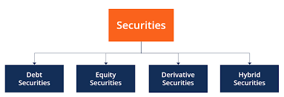

Securities are financial instruments which are traded in financial markets. Ex: debt, equity, derivative, and hybrid securities.

**What is securities clearing and settlement?**

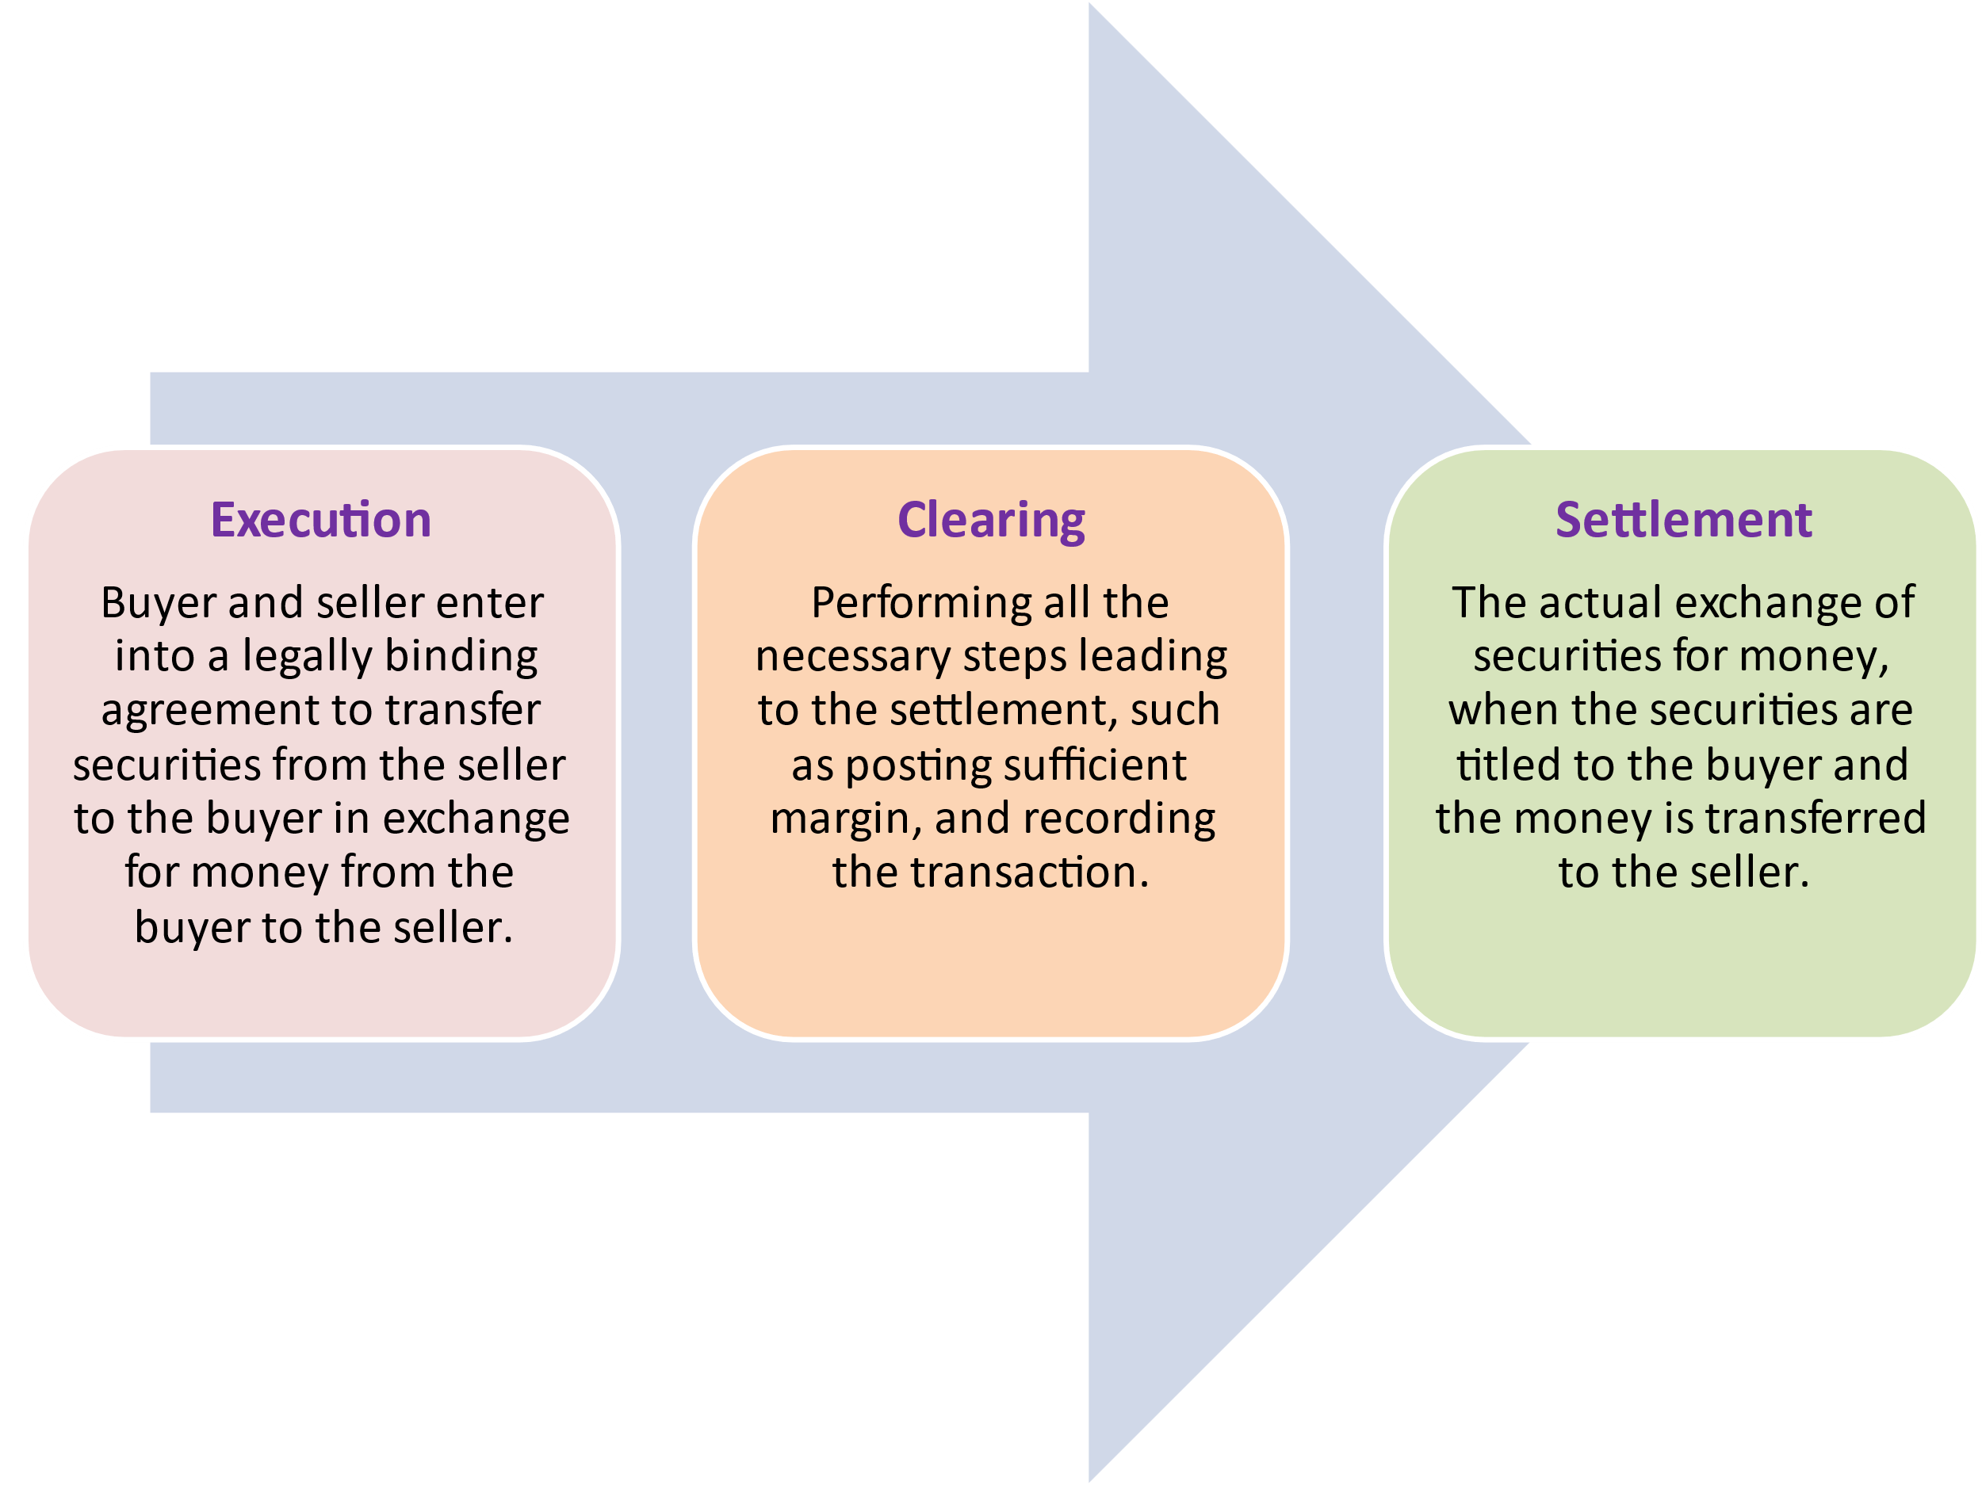

Settlement is the actual exchange of money, or some other value, for the securities.

**Securities Transaction**

Securities

CSD

Seller

Buyer

Payment

**Central Securities Depositors Regulation (CSDR)**

CSDR : The aim of CSDR is to harmonize certain aspects of the settlement cycle and settlement discipline and to provide a set of common requirements for CSDs operating securities settlement systems across the EU

**Central Securities Depositors(CSD)**

CSDs are responsible for safekeeping of securities and settlement of securities transfers in the post-trading stage. Securities of such shares are transferred in certificated or uncertificated (dematerialized) form.

Appendix:

Transaction

|  |  |  |
| --- | --- | --- |
| Name | Type | Description |
| Place of Holding Tech number | Smallint | 10 |
| ISIN | CHAR (12) | ANN4327C1220 |
| Security quantity | int |  |
| Transaction Type Code | CHAR(4) | TRAD |
| Instruction Type code | CHAR(4) | DVP |
| Matching Reference | CHAR(16) | 776702220230112 |
| Settlement Date | Date |  |
| Settlement cash amount | Decimal |  |
| Calendar Id | CHAR (10) |  |
| Party Id | Char(16) | 1981854 |
| Counter Party Id | Char(16) | 4794041 |
| Party Role Cd | Char(6) | Seller |
| Counter Party Role Cd | Char(6) | Buyer |
| Failing Party Role Cd | Char(6) | Seller |
| Penalty Amount | Decimal |  |
| Sign | Bit | + or - |

Holiday Calendar

|  |  |  |
| --- | --- | --- |
| Name | Type | Description |
| ID | CHAR(10) | Uniquely identify each record  ADELAIDE, ALMATY, AUCKLAND, BAHAMAS, BANGKOK, BRISBANE, CALGARY, CANBERRA, CARDIFF, CHANNEL IS, DUBLIN, GHANA |
| Holiday Date | Date | Ex: 2023-10-03 |
| Last Updated Date | Date |  |

Security Price

|  |  |  |
| --- | --- | --- |
| Name | Type | Description |
| ID | Bigint | Uniquely identify each record |
| POH | Smallint | Ex : 10 |
| ISIN SEC ID | CHAR (12) | EX : USF2R125CF03, DE000GS4YDA7, 98,87, 80, 72, DE000GS6YAU6, AT8, AS0, AR2, AQ4, AP6, AN1, AM3, AL5, AK7, AH3, AF7, AE0 , DE000GS8Y808, 816, 824, 790, 782, 766, 717, 709, 691, DE000GS9Y814, 806, 798, 780,772,764, 765,749, NL0010505350, FR0011952100 |
| VALID FROM DATE | DateTime | Price Applicable from Date |
| Security Price | DECIMAL |  |

Security Penalty Rate

|  |  |  |
| --- | --- | --- |
| Name | Type | Description |
| ID | Bigint | Uniquely identify each record |
| VALID FROM DATE | DateTime | Price Applicable from Date |
| Penalty Rate | Decimal |  |
| Last Updated Date | Date |  |